Project Name: Fineos Life/Waiver
Author: Pravin Patil
Technical Design Document - ALFRESCO

Table of Contents
Purpose/Overview 2
Scope 2
Helpful Information 2
Technical Design Checklist 2
System Architecture 4
Email Processing 4
Document Indexing 4
Guided Forms 4
List all third-party integrations: 5
File, Table, and Database Design 6
Technical Design 6
1. Email Processing: 6
1.1. Landing Zone: 6
1.2. Alfresco content model (Data model): 7
1.3. Alfresco Folder taxonomy: 8
1.4. Alfresco security model: 9
1.5. Incoming Email processor 9
1.6. User Interface for L & W: 10
1.7. Rightfax Integration: 11
1.8. Document Indexing 11
1.9. Guided Forms 11
2. Alfresco Migration Tool (Migration of Legacy data) 12
Interface Design 14
Outline the process to handle errors between interfaces (if applicable) 15
Security Requirements 15
1. Network Communications 15
Testing Considerations 16
Link to Master Test Plan: 16
Monitoring and Logging 16
Operationalizing Considerations (Required for CAB Approval) 16

Purpose/Overview
The High-Level Design (HLD) is intended to provide clarity around functional requirements as well as additional technical requirements that may be needed to complete development. This document will provide implementation details related to all aspects of the Alfresco Implementation of email processor and migration of legacy data related to the Fineos Life/Waiver project.

The High-Level Design (HLD) document is intended to:

- Clarify functional and technical requirements.
- Align requirements to the solution via a conceptual architecture.
- Identify integrations needed.
- Align APIs to the conceptual architecture.
- Serve as a guide for creating of necessary stories to complete development.

The implementation must align to and produce the results illustrated within this document.

Scope
The scope of this technical design is limited to the Alfresco data model, security model, email processor and legacy migration that will be required for usage within processing of Fineos Life Waiver and Disability Claims. Alfresco will be used for storing the documents and indexing to FINEOS. This will replace AWD, which is currently being used for EB Life & LWOP claims.

Helpful Information
Technical Solution Owner | Kiran Tammareddy
Date Created | 04/18/2025
Project Number | PRJ0131917
Project Name | EB Life and Life Waiver of Premium
# of Technologies Impacted with this effort | 6 - Alfresco, AWS EC2, Mulesoft, Microsoft Exchange, Amazon SQS, MSSQL Server
Ongoing Support Team | Alfresco support
Integration type | New and existing modifications to existing applications.

Technical Design Checklist
This checklist is for the TSO/system architect to understand the expectations of completing the technical design prior to presenting to TRB for approval.

Checklist Item | Complete?
TSO scheduled meeting for SA to review SD with the TSO, BA, Lead Dev, ADA (if applicable), and SQA | ☐
Aligned with PM on timeline based on estimate to complete. | ☐
Ongoing support team has been notified of the changes that will impact their team after implementation. | ☐
Knowledge transfer with the appropriate team scheduled, if necessary, for big projects. | ☐
Plan in place for existing formal application documentation (Application Infrastructure Repository in SharePoint) to be updated with all pertinent information from the TDD. | ☐
TSO has consulted with the Robotics team to ensure that either 1) No Robots will be impacted by the work being done or 2) The TSO has notified the Robotics team prior to execution beginning. | ☐
Third-party integrations called out (if applicable) | ☐
The TDD will be attached to the TRB Review Request to give the TRB members time to review prior to the TRB review. | ☐
Ensure an implementation back-out plan is in place. | ☐

System Architecture
The Alfresco email processing integrations with the FINEOS administrative system vary based upon the subject area. For example: Data retrieval has a different style of integrations versus email processing. There are four different subject areas involved with processing either “from” or “to” FINEOS. Each existing subject area will require changes with the introduction of Life/Waiver within FINEOS.

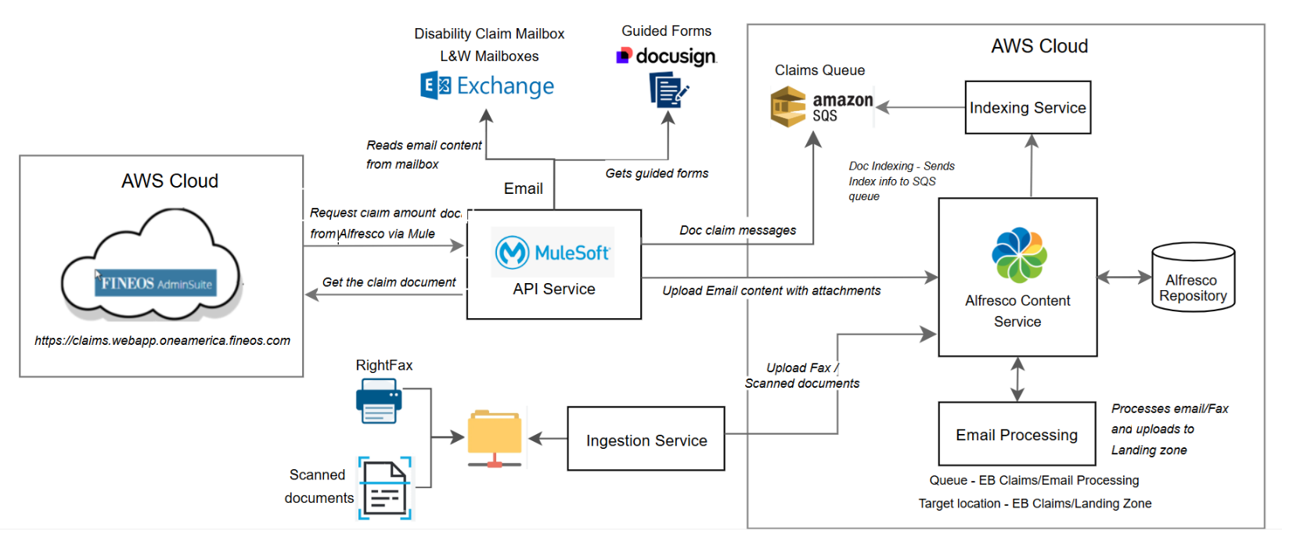
Diagram #1 – Alfresco Technical Design Architecture

Email Processing
Once data retrieval is completed via service calls, Mulesoft API reads claim emails from specific mailboxes and uploads the email content with attachements to Alfresco Landingzone folders for preservation and indexing.

Document Indexing
Document indexing references the post-arrival processing of claimant communications that was received via email, fax, or standard mail and has been processed into Alfresco. The typical processes incorporated within document indexing involve uploading document identifiers and work task creation to FINEOS.

Guided Forms
Guided forms processing references an electronic form submission process has been created within Docusign. Specific forms that have been established within Docusign as fillable forms that are automatically submitted to OneAmerica upon signing, perform additional delivery tasks upon reception at OneAmerica.

Disability Claims guided form processing already interrogates FINEOS to determine whether an individual may already exist in FINEOS before determining whether to create a new user within FINEOS. Whether a new user was created determines whether uploading Docusign delivered documents to one of two Alfresco landing zones which identifies whether additional action may be necessary by the claims processor.

List all third-party integrations:
Mulesoft
Fineos
Amazon SQS
AWS EC2
Alfresco

File, Table, and Database Design
This is part of separate FIneos Life/Waiver Technical Design Document for Data / ETL / SSRS and is not part of this document. Please reference that document.

Functional  Req. ID | Technical Req. ID | Technical Description
N/A | N/A | No custom database involved or custom tables created for Alfresco related changes.

Technical Design
This document will clarify the functional and technical requirements associated with each FINEOS integration subject area, in addition to providing clarifying examples.

Email Processing:

Landing Zone:
This section outlines the technical implementation for setting up Alfresco landing zones to support email processing of claim documents for EB Life and LWOP products, including folder structure creation, security configuration, and integration requirements.

/Company Home
└── /EB Claims
│
├── /Email Processing
│ ├── /Inbound
│ ├── /Processed
│ └── /Failed
│
├── /Email Processing Home Office
│ ├── /Inbound
│ ├── /Processed
│ └── /Failed
│
├── /Landing Zones
│ ├── /Disability
│ ├── /EB Life
│ ├── /EB Waiver
│ ├── /EB Life and Waiver Home Office
│
│
└── /Web API Landing Zones – To store Guided forms
│ ├── /Disability
│ ├── /EB Life
│ ├── /EB Waiver
│ ├── /EB Life and Waiver Home Office
│
└── /FINEOS Images
│
└── /FINEOS Images Home Office

Email processor will route the documents to appropriate Landing Zone based on the incoming Email address as specified in the below spreadsheet.

Claim Type | Folder Identification | Processing Folder
Disability | Disability-claims | /EB Claims/Email Processing/Inbound/Disability-claims-<YYYYMMDDHHMMSS>
EB Life | Life-claims | /EB Claims/Email Processing/Inbound/Life-claims-<YYYYMMDDHHMMSS>
EB Waiver | Waiver-claims | /EB Claims/Email Processing/Inbound/Waiver-claims-<YYYYMMDDHHMMSS>
EB Life and Waiver Home Office | LifeHomeOffice-claims | /EB Claims/Email Processing Home Office/Inbound/ LifeHomeOffice-claims-<YYYYMMDDHHMMSS>
ILFS Waiver | ILFSWaiver-claims | /EB Claims/Email Processing/Inbound/ILFSWaiver-claims-<YYYYMMDDHHMMSS>

Based on Claim Type and folder identification, the document folder will be created with below format

<Claim Type Folder Identificaiton>-<YYYYMMDDHHMMSS>

Alfresco content model (Data model):
This design defines a custom Alfresco content model for the Fineos Life & Waiver (L&W) implementation, including all required metadata properties with appropriate data types, constraints, and associations.

Property | Value
Model Name | lwModel
Namespace | http://www.fineos.com/model/lw/1.0
Prefix | eb
Primary Type | eb:lwdoc

The properties are listed below

Property | Type | Constraints | Indexing | Notes
eb:documentId | Text | Mandatory | Atomic | Unique identifier for documents
eb:documentType | Text | Predefined list | - | Restricted to valid document types
eb:documentTag | Text | Predefined list | - | Restricted to valid document types
eb:claimNumber | Text | - | Enabled | Frequently searched field
eb:claimType | Text | - | - | Restricted to valid claim types
eb:receivedDate | Datetime | - | - | ISO 8601 format
eb:author | Text | - | - | Original document author

Some of the properties will be inherited from cm:content parent type

- Inherits from cm:content to get default Alfresco properties:
- cm:name (file name)
- cm:title (display title)
- cm:creator, cm:created (audit fields)
- cm:modifier, cm:modified (audit fields)

Alfresco Folder taxonomy:
This design implements a hierarchical folder structure in Alfresco to organize documents with clear separation between physical uploads (Landing Zones) and system-generated files (Web API Landing Zones).

Email Processing:
- Inbound: The source documents uploaded Inbound folder by Mule API
- Processed: Once it is processed, documents are moved to Processing folder
- Failed: The failed documents are moved to this location

Landing Zone: Once documents are processed successfully and converted to pdf format, it is moved to Landing Zone subfolder based on claim type

Web Landing Zone: The guided forms are stored based claim type

/Company Home
└── /EB Claims
│
├── /Email Processing
│ ├── /Inbound
│ ├── /Processed
│ └── /Failed
│
├── /Email Processing Home Office
│ ├── /Inbound
│ ├── /Processed
│ └── /Failed
│
├── /Landing Zones
│ ├── /Disability
│ ├── /EB Life
│ ├── /EB Waiver
│ ├── /EB Life and Waiver Home Office
│
│
└── /Web API Landing Zones – To store Guided forms
│ ├── /Disability
│ ├── /EB Life
│ ├── /EB Waiver
│ ├── /EB Life and Waiver Home Office
│
└── /FINEOS Images
│
└── /FINEOS Images Home Office

Alfresco security model:
This design establishes a role-based access control (RBAC) model for organizing documents in the Alfresco repository with appropriate permissions for the Fineos Life & Waiver (L&W) implementation.

Folder level permission: The user access is controlled based on folders Email Processing, Landing Zone, Web API Landing Zone.

Specifiy group names
Claims | Alfresco groups
Disability | eb_disability_read, eb_disability_write, eb_disability_manager
EB Life | eb_life_read, eb_ life_write, eb_ life_manager
EB Waiver | lw_ebwaiver_read, eb_ waiver_write, eb_ ebwaiver_manager
EB Life and Waiver Home Office | eb_lifewaiver_homeoffice_read, eb_lifewaiver_homeoffice_write, eb_lifewaiver_homeoffice_manager
ILFS Waiver | eb_ilfswaiver_read, eb_ ilfswaiver_write, eb_ ilfswaiver_manager

Incoming Email processor
Provide approaches for reading email messages that are sent to Microsoft Exchange mailboxes by claimants and deliver the message content to Alfresco for ingestion processing by Claims technicians. The reading of mailboxes will be identical to what is currently being done for processing mailbox messages for Disability Claims.

There will be no defined API endpoints required for the processing.

Email Processing Folder Structure
  - Root Email Processing Folder: /Company Home/EB Claims/Email Processing
    - Inbound Folder: /Email Processing/Inbound
      - Subfolders: <claim folder Identification>-<YYYYMMDDHHMMSS> (dynamic creation) – to store email content
    - Processed Folder: /Email Processing/Processed
    - Failed Folder: /Email Processing/Failed
Flow diagram for Email processing:

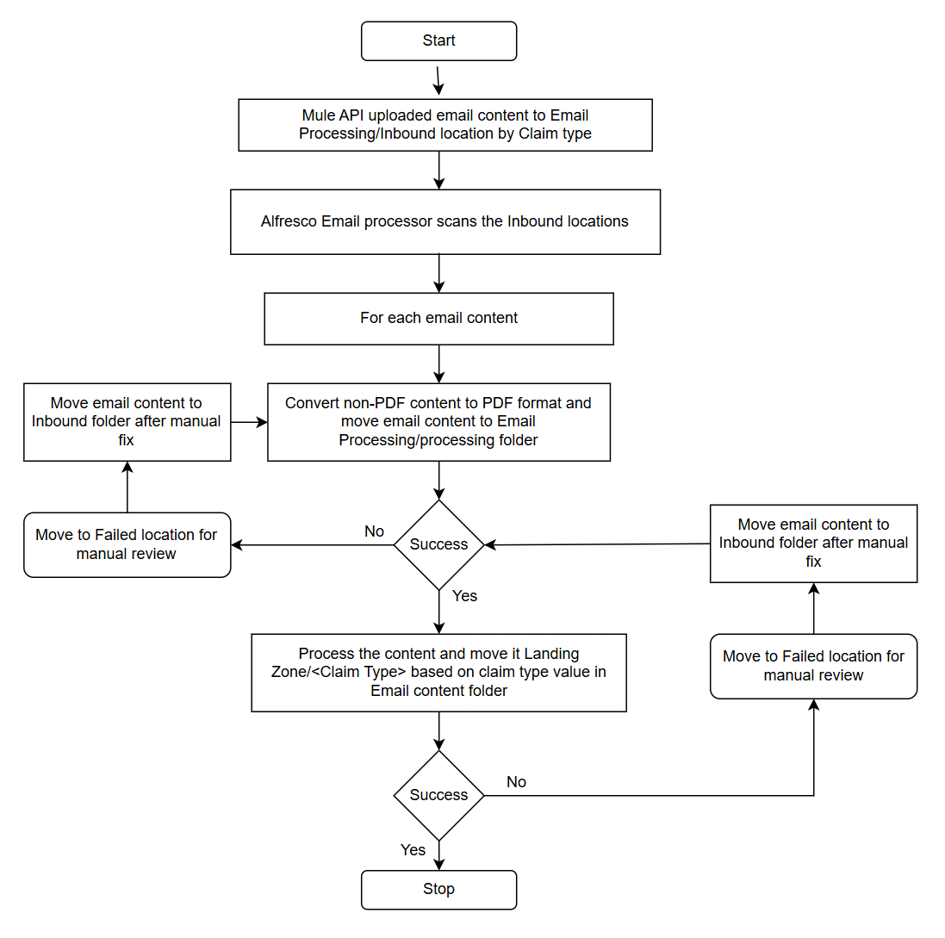
Claim Types:
- Disability
- EB Life
- EB Waiver
- EB Life and Waiver Home Office
- ILFS Waiver

User Interface for L & W:
The proposed solution extends the existing Alfresco ADF-based UI, currently used for Disability Claims, to support Employee Benefits (EB) Claims for Life and Waiver documents. A new folder structure (EB_Claims/ with subfolders for Claim types(Disability, EB Life, EB Waiver, EB Life and Waiver Home Office, ILFS Waiver) will be implemented in Alfresco, organized by Claim_ID for better document segregation.
The security model will introduce role-based access controls (READ, WRITE and MANAGER) to ensure authorized access while reusing existing ADF components for document viewing, uploading, and searching with minimal modifications.

The implementation involves deploying the folder structure via Alfresco APIs, updating ADF UI filters to include EB document types, and rolling out changes through CI/CD pipelines. This approach ensures a seamless integration with the current Disability Claims workflow while maintaining security, scalability, and a consistent user experience. Testing will focus on permissions, folder navigation, and document management to validate functionality before production release.

The solution delivers a structured, secure, and efficient way to manage EB Claims documents without disrupting existing operations.

Rightfax Integration:
The existing fax processing workflow for disability claims will be extended to support Life and Waiver documents, maintaining consistency and efficiency. RightFax will continue depositing incoming faxes into the designated shared drive location, while scanned documents will be staged in their respective network folders. The current ingestion tool, already configured to monitor these locations, will process both faxed and scanned documents similarly to the disability claims process. Documents will be uploaded to Alfresco with appropriate metadata and filed under the corresponding Life or Waiver claim folders, ensuring seamless integration with the established document management framework.

This approach minimizes development effort by reusing the proven disability claims processing pipeline, including metadata extraction, and error handling. The solution maintains security and compliance through existing access controls and audit trails while accommodating the new document types. By leveraging the current infrastructure, we ensure rapid deployment and operational familiarity, reducing training needs and maintaining system stability as we expand support to Life and Waiver claims.

Document Indexing
Document indexing references the post-arrival processing of claim communications received via email, fax, or standard mail and have been indexed into Alfresco with appropriate tagging by the rotating claims processor. Once a communication has been indexed into Alfresco, the typical processes involve uploading document identifiers and creating work tasks within FINEOS.

- Alfresco places document indexing message on Amazon SQA queue setup with Disability Claims.
- Mule service reacts to indexing message on Amazon SQS queue and processes into FINEOS.

Changes associated with Life/Waiver are limited to addressing the functional changes necessary for FINEOS authorization and improving separation of error handling between different concerns (HTTP, queue processing).

Guided Forms
Guided forms processing currently exists for Disability Claims and EB Life Claims within Docusign. Each form type is considered as part of Life/Waiver, but the current paths of execution handling between the two form types is different.

- Disability Claims form processing checks for the individual in FINEOS before delivering to one of two landing locations in Alfresco for document indexing.
- Existing EB Life Claims form processing currently goes directly to AWD.

Alfresco Migration Tool (Migration of Legacy data)
This document outlines the technical design of an Alfresco migration tool that extracts files and metadata from a shared drive, transforms them into Alfresco-compatible format, and loads them into Alfresco in a structured L&W (Life and Waiver) folder hierarchy. The Assumption is AWD Oracle and Microsoft access data will be provided in CSV format with file path to shared drive location.

The migration tool consists of three main modules:

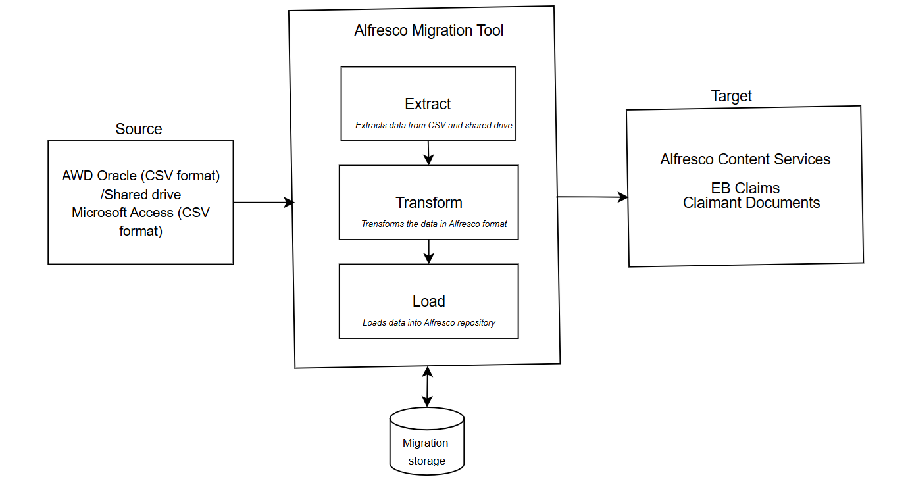
Diagram #3 –Alfresco Migration Service Design

- Extractor Module: Reads metadata from a CSV file, locates files on a shared drive, and stores them in a temporary migration storage.
  - Input:
CSV file with columns:
file_path (shared drive location)
metadata_field1, metadata_field2, ... (custom metadata)
  - Process:
Parse CSV and validate required fields.
For each row:
Locate file on shared drive using file_path.
Copy file to temporary migration storage.
Store metadata in a structured format (JSON or intermediate CSV).
  - Output:
Files copied to temporary storage.
Metadata stored in a structured format for transformation.
  - Error Handling:
Log missing files.
Skip corrupt entries with error reporting.

Metadata Mapping from source to target:

CSV Field | Alfresco Property | Data Type | Description
name | cm:name | String | File name (without extension)
title | cm:title | String | Document title
documentId | eb:documentId | String | Unique document identifier
documentType | eb:documentType | String | Type of document (e.g., Policy, Claim, Waiver)
documentTag | eb:documentTag | String | Tags for categorization
claimNumber | eb:claimNumber | String | Associated claim reference
receivedDate | eb:receivedDate | Date | Date document was received
modifiedBy | eb:modifier | String | Last user who modified the document
createdBy | eb:creator | String | User who created the document
modifiedDate | eb:modified | Date | Last modification timestamp
createdDate | eb:created | Date | Document creation timestamp
author | eb:author | String | Original author of the document

- Transform Module: Converts extracted data into Alfresco Bulk Filesystem Import format, applies metadata, and prepares folder structure.
  - Input:
Extracted files + metadata from temporary storage.
  - Process:
Folder Structure Preparation:
Generate Alfresco-compatible paths.
Apply naming conventions.
Metadata Mapping:
Convert CSV metadata to Alfresco properties (e.g., cm:title, fineos:documentType).
Bulk Import Format Conversion:
Generate .metadata.properties files for each document.
Structure files as per Alfresco’s Bulk Filesystem Import requirements.
  - Output:
Folder hierarchy in temporary storage.
Files with associated .metadata.properties.

- Loader Module: Imports the transformed data into Alfresco under the L&W folder structure.
Input: Transformed data in Bulk Import format.
Process:
Alfresco Bulk Import:
Use Alfresco’s FileSystemImportService for high-performance loading.
Configure import to preserve folder structure (L&W/...).
Post-Load Validation:
Verify successful document creation.
Log failures for manual correction.
Output:
Documents and metadata loaded into Alfresco.
Audit log of migration status.

Interface Design
All interface changes will be identified during Service Integration API design and review at later date.

Functional  Req. ID | Technical Req. ID | Technical Description
N/A

Outline the process to handle errors between interfaces (if applicable)
Example: Call to an API, how are retries handled? If a queue is used, who will manage?

Security Requirements

Functional  Req. ID | Technical Req. ID | Technical Description
 | 1 | All service calls originating from Fineos to OneAmerica will be secured via OAuth and IP Whitelisting security policies.
 | 2 | All service calls originating from OneAmerica to Fineos will OAuth authenticate first with Fineos before making calls which will also be secured with IP Whitelisting security policies on Fineos side.

Network Communications

Service | Ports | Protocol
All services | 443 | HTTPS

Testing Considerations
Outline any testing considerations that are needed beyond testing of the defined requirements. This could include testing that is particularly complicated and may need special attention. Could also include cross-platform testing situations.

Link to Master Test Plan:
To be determined.

Monitoring and Logging
Outline any logging, monitoring, and business metrics that should be communicated to the ongoing support team that will be maintaining these changes.

Operationalizing Considerations (Required for CAB Approval)

What team is responsible for maintaining the changes? | Steady state team for EB Claims.
Has this project team discussed the upcoming changes with the leader of the team expected to maintain these changes? | No. Project is only in initiation phase.
Number of additional hours (approximately) expected from these changes?
Is the team currently staffed appropriately to handle these additional changes? | No. Already initiating discussion.
Will additional headcount be needed to maintain these changes once implemented? | No.
Who has been appointed responsible for documenting the process changes in an approved OAWay document?
What training is needed? | Steady state team will need to build familiarity with reading of the email mailboxes and Azure Service Bus queue messages.

